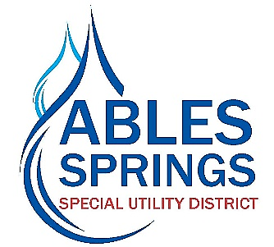

Adopted by the majority vote of the Board of Directors for the Ables Springs Special Utility District on the 21st day of August, 2024, the District’s water rates will increase effective **October 1, 2024** at the rates listed below.

**Tiered Rates Per Thousand Gallons**

**Current Rate New Rate**

Monthly Minimum Charge (No Water Usage) – 42.50 Monthly Minimum Charge (No Water Usage) – 46.00

Standard Service Water Rates (5/8” x ¾”) Standard Service Water Rates (5/8” x ¾”)

0-2,000 gallons--------------$7.00/thousand gallons 0-2,000 gallons-------------$7.25/thousand gallons

2,001-6,000 gallons--------$8.00/thousand gallons 2,001-6,000 gallons-------$8.25/thousand gallons

6,001-10,000 gallons------$9.50/thousand gallons 6,001-10,000 gallon-------$9.75/thousand gallons

10,001-20,000 gallons----$11.50/thousand gallons 10,001-20,000 gallons----$11.75/thousand gallons

20,001-40,000 gallons----$12.50/thousand gallons 20,001-40,000 gallons----$12.75/thousand gallons

Over 40,000 gallons-------$14.50/thousand gallons Over 40,000 gallons-------$14.75/thousand gallons

The District hereby gives the required thirty-day notice via publication in the local newspaper for two consecutive weeks and is providing notice on the utility bills with a direct link to the Districts website, and a public notice at the Districts business office located at 30100 FM 429, Terrell, TX 75161.