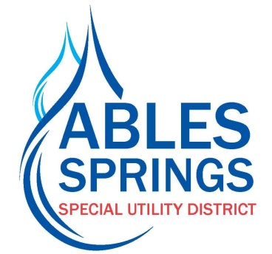

Bank Draft Authorization Form

NAME
ASSUD Account #

Bank Name
Circle One: Checking
Savings

Bank Account #
Routing #

I authorize Ables Springs SUD, hereinafter called DISTRICT, to initiate debit entries to my checking or savings account indicated below at the depository named above, hereinafter called DEPOSITORY, to debit the same to such account. This authorization will remain in full force and effect until DISTRICT has received written notification from me of its termination in such time and in such manner as to afford DISTRICT and DEPOSITORY a reasonable opportunity to act on it.

Signature Date

Please return completed form along with a voided check to the office.

