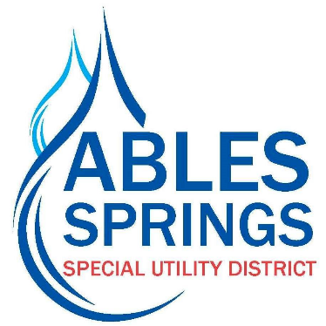

Adopted by the majority vote of the Board of Directors for the Ables Springs Special Utility District on the 20th day of September, 2023, the District’s water rates will increase effective November 1, 2023 at the rates listed below.

Tiered Rates Per Thousand Gallons
Current Rate New Rate
Monthly Minimum Charge (No Water Usage) -$39.50 Monthly Minimum Charge (No Water Usage) -$42.50
Standard Service Water Rates (5/8” x3/4”) Standard Service Water Rates (5/8” x3/4”)

0-2,000 gallons ------------$6.40/thousand gallons 0-2,000 gallons ------------$7.00/thousand gallons
2,001-6,000 gallons ------ $6.90/thousand gallons 2,001-6,000 gallons ------ $8.00/thousand gallons
6,001-10,000 gallons ----$9.15/thousand gallons 6,001-10,000 gallons -----$9.50/thousand gallons
10,001-20,000 gallons ---$9.40/thousand gallons 10,001-20,000 gallons ---$11.50/thousand gallons
20,001-40,000 gallons ---$10.65/thousand gallons 20,001-40,000 gallons ---$12.50/thousand gallons
Over 40,000 gallons ------ $12.40/thousand gallons Over 40,000 gallons ------ $14.50/thousand gallons

Standard (5/8”x3/4”) Meter Tap Fee --------$5,475 Standard (5/8”x3/4”) Meter Tap Fee --------$6,150

The District hereby gives the required thirty-day notice via publication in the local newspaper for two consecutive weeks and is providing notice on the utility bills with a direct link to the District’s website, and a public notice at the District’s business office located at 30100 FM 429, Terrell, TX 75161.

